Modify DAX filter context in Power BI
Use the CALCULATE function to manipulate filter context.
Download and Open Day2\Lab2\Lab 2 Starter-Sales Analysis.pbix file
Create a matrix visual
In this task, you’ll create a matrix visual to support testing your new measures.
- In Power BI Desktop, create a new report page.
- On Page 3, add a matrix visual.
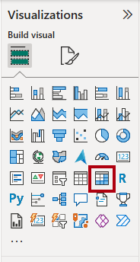
- Resize the matrix visual to fill the entire page.
- To configure the matrix visual fields, from the Data pane, drag the Region | Regions hierarchy, and drop it inside the visual.
- Add the Sales | Sales field to the Values well.
- To expand the entire hierarchy, at the top-right of the matrix visual, select the forked-double arrow icon twice.
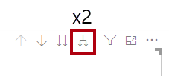
- To format the visual, in the Visualizations pane, select the Format pane.
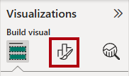
- In the Search box, enter Layout.
- Set the Layout property to Tabular.
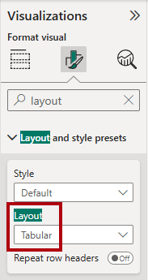
- Verify that the matrix visual now has 4 column headers.
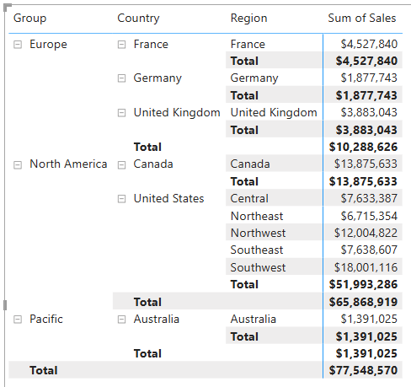
You’ll create various measures in this exercise, and then test them by adding them to the matrix visual.

Manipulate filter context
In this task, you’ll create several measures with DAX expressions that use the CALCULATE function to manipulate filter context.
- Add a measure to the Sales table, based on the following expression:
Sales All Region =
CALCULATE(
SUM(Sales[Sales]),
REMOVEFILTERS(Region)
)
- Add the Sales All Region measure to the matrix visual.
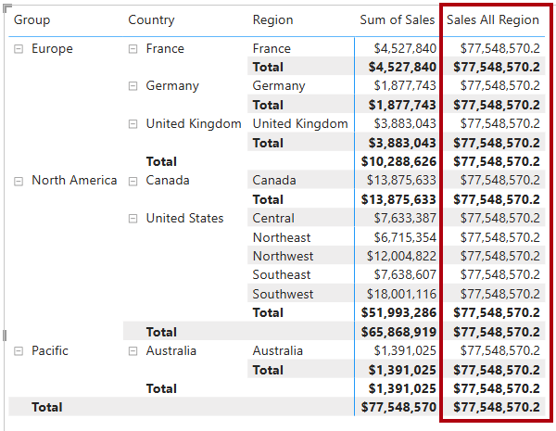
- Notice that the measure computes the total of all region sales for each region, country (subtotal) and group (subtotal).
- In the Data pane, ensure that the Sales All Region measure is selected (when selected, it will have a dark gray background), and then in the formula bar, replace the measure name and formula with the following formula:
Sales % All Region =
DIVIDE(
SUM(Sales[Sales]),
CALCULATE(
SUM(Sales[Sales]),
REMOVEFILTERS(Region)
)
)
- In the matrix visual, notice that the measure has been renamed and that a different value now appears for each group, country, and region.
- Format the Sales % All Region measure as a percentage with two decimal places.
- In the matrix visual, review the Sales % All Region measure values.
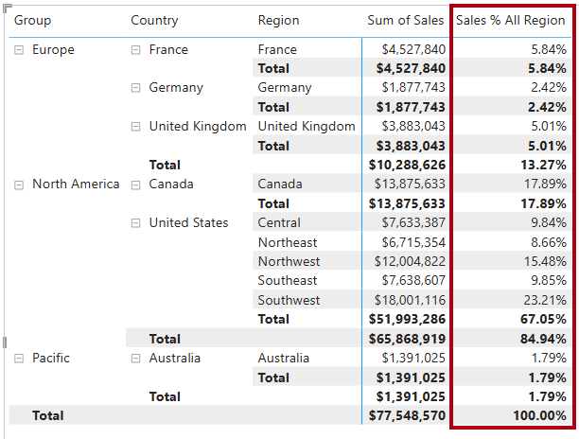
- Add another measure to the Sales table, based on the following expression, and format as a percentage:
Sales % Country =
DIVIDE(
SUM(Sales[Sales]),
CALCULATE(
SUM(Sales[Sales]),
REMOVEFILTERS(Region[Region])
)
)
- Notice that the Sales % Country measure formula differs slightly from the Sales % All Region measure formula.
- Add the Sales % Country measure to the matrix visual.
- Notice that only the regions of the United States produce a value that isn’t 100 percent.
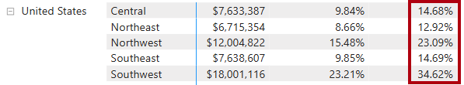
- To improve the readability of this measure in visual, overwrite the Sales % Country measure with the following improved formula.
Sales % Country =
IF(
ISINSCOPE(Region[Region]),
DIVIDE(
SUM(Sales[Sales]),
CALCULATE(
SUM(Sales[Sales]),
REMOVEFILTERS(Region[Region])
)
)
)
- Notice that the Sales % Country measure now only returns a value when a region is in scope.
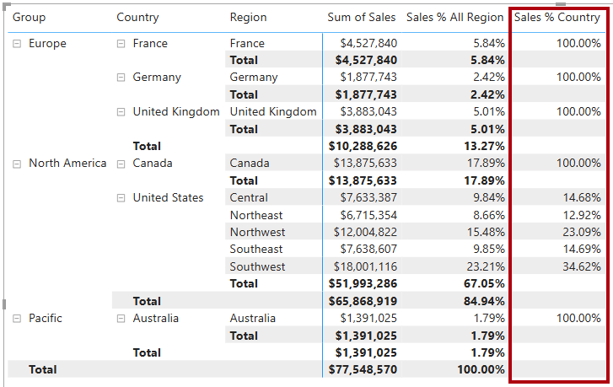
- Add another measure to the Sales table, based on the following expression, and format as a percentage:
Sales % Group =
DIVIDE(
SUM(Sales[Sales]),
CALCULATE(
SUM(Sales[Sales]),
REMOVEFILTERS(
Region[Region],
Region[Country]
)
)
)
- Add the Sales % Group measure to the matrix visual.
- To improve the readability of this measure in visual, overwrite the Sales % Group measure with the following formula.
Sales % Group =
IF(
ISINSCOPE(Region[Region])
|| ISINSCOPE(Region[Country]),
DIVIDE(
SUM(Sales[Sales]),
CALCULATE(
SUM(Sales[Sales]),
REMOVEFILTERS(
Region[Region],
Region[Country]
)
)
)
)
- Notice that the Sales % Group measure now only returns a value when a region or country is in scope.
- In Model view, place the three new measures into a display folder named Ratios.
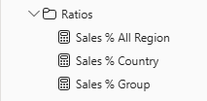
- Save the Power BI Desktop file.

